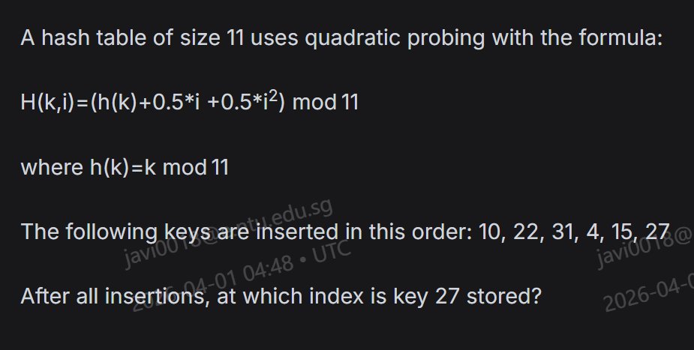
- 5
- 6
- 7
- 8

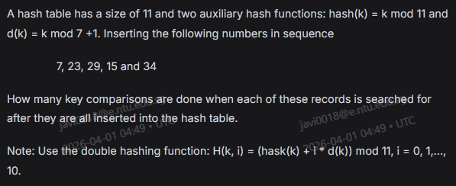
- 6
- 7
- 8
- 9

- O(log n)
- O(k log n)
- O(k)
- O(n)
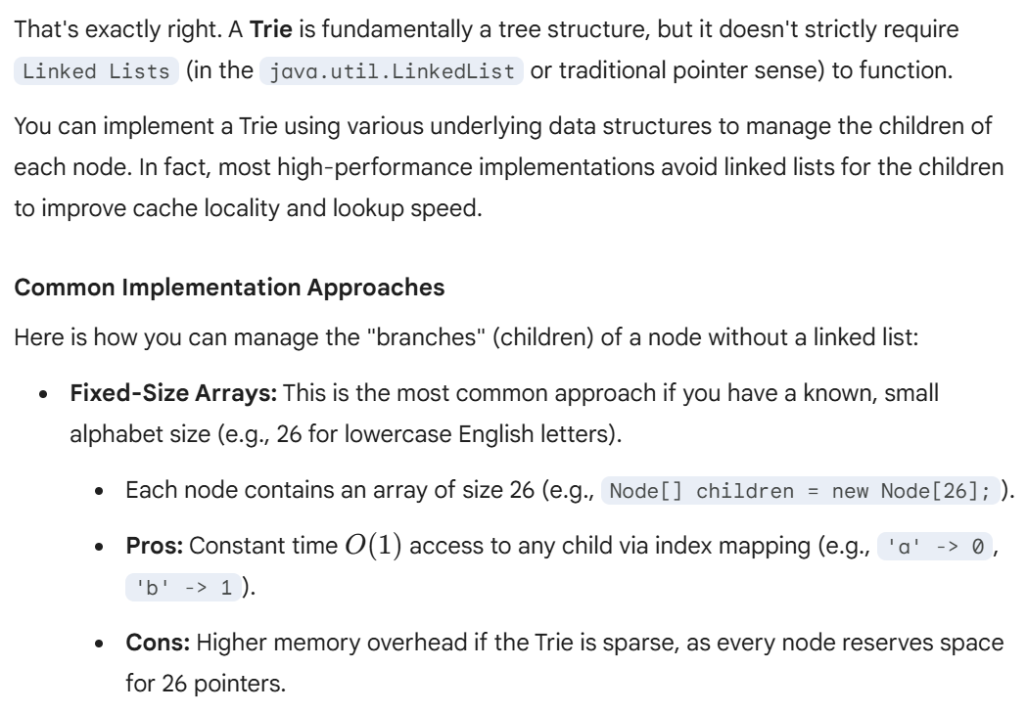
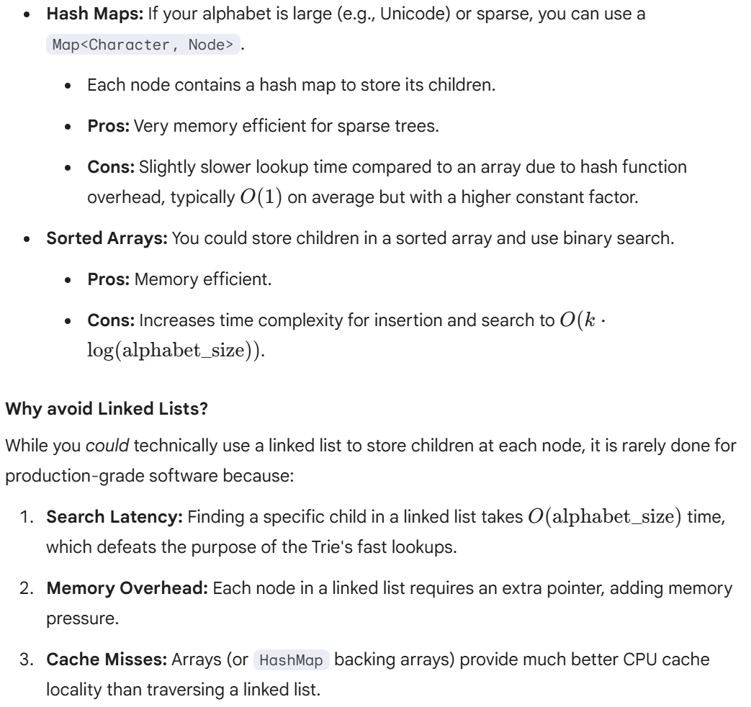

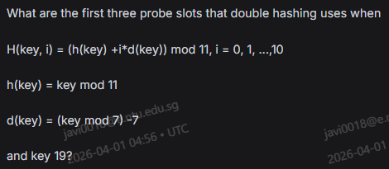
- Slot 8, 6, 4
- Slot 8, 10, 12
- Slot 6, 4, 2
- Slot 10, 12, 14

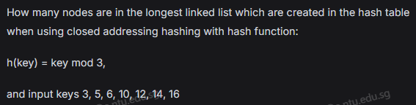
- 2
- 3
- 4
- 5

